Quiz 4 SVM and Kernel Method
- Linearly Separable Example (10 points)
Build the best SVM linear classifier for the following (tiny) data set shown in Figure below. Show your solutions for w and b. It is required that you solve the margin ρ=2/|w|. Add your SVM decision boundary on the figure below. Note that there are three instances, each with two features, and this is a binary classification problem.
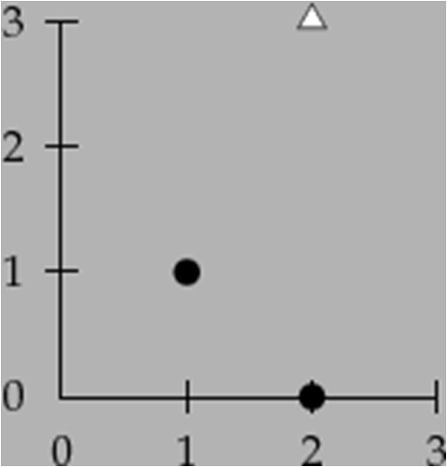

Solution:

W1 = 2/5
W2 = 4/5
b = -11/5
ρ = 2.236
Decision boundary Equation: X1 + 2X2 =5.5
Support Vector Equations:
X1 + 2X2 = 3
X1 + 2X2 =8

